**Task 1 - Items control**

**Task description**

Create a function that can add, search and remove items from a list

* The function takes two parameters:
  + A **selector** that can be any CSS3 selector:
    - By id -#id
    - By class - .class
    - By node type - div
    - Or nested selectors - #this .is a .nested.selector
  + A **isCaseSensitive** that sets the case-sensitivity of the search
    - Possible values are true and false
    - Has a default value false

The following must be implemented:

* Adding an item
* Removing an item
* Searching items by a pattern
  + The search can be either **case-sensitive** or **case-insensitive**

1. **Adding elements** part must consist of an element with class add-controls, that contains:
   * Text “Enter text”
   * An input element
   * An element with class button and content ‘Add’
   * By clicking the element with class button, a new item element with class list-item should be added to the element with class items-list (_see 3. Result elements section__)
     + An element with class list-item must be added to the element with class items-list
2. **Search elements** part must consist of an element with class search-controls, that contains:
   * Text “Search”
   * An input element
   * Typing in the input must refresh the contents of the element with class result-controls
     + Hides all the elements with class list-item that does not contain **the value** of the input
       - The search can be either **case-sensitive** or **case-insensitive**, depending on the isCaseSensitive parameter
       - **Hide the elements with display: none, otherwise, it will not be evaluated as correct!**
3. **Result elements** part must consists of an element with class result-controls, that contains:
   * An element with class items-list
   * The items-list element contains zero or many elements with class list-item
   * Each element with class list-item contains of:  
     * A text, that is taken from the input in the element with class add-controls  
     * An element with class button, that has a content ‘X’ (capital ‘x’)
   * By clicking any of the elements with class button in an element with class list-item:
     + The element with class list-item that contains this button element, **must be deleted**

**Addintional remarks**

* Use display: none to hide elemens
* Do not use classList
* Do not use innerText or textContent()

**Solution template**

Your solution must follow the template:

function solve(){

return function(selector, isCaseSensitive){

//your code here

};

}

**Examples**

*Example usage 1:*

<div id="root"></div>

<script>

solve()('#root');

</script>

*Example usage 2:*

<div id="root"></div>

<script>

solve()('#root', true);

</script>

*Examples:*

* With some items added:

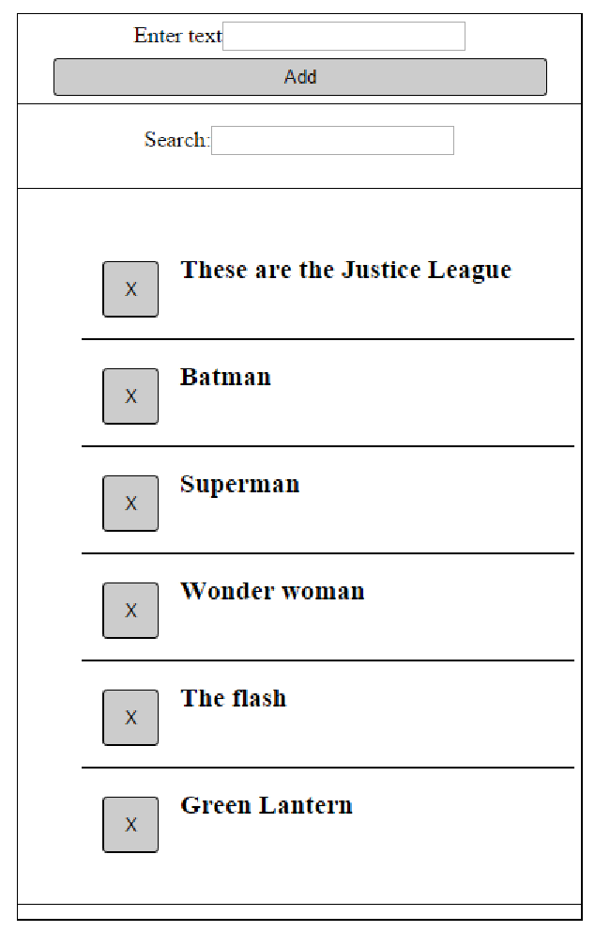

* With search pattern, case-insensitive

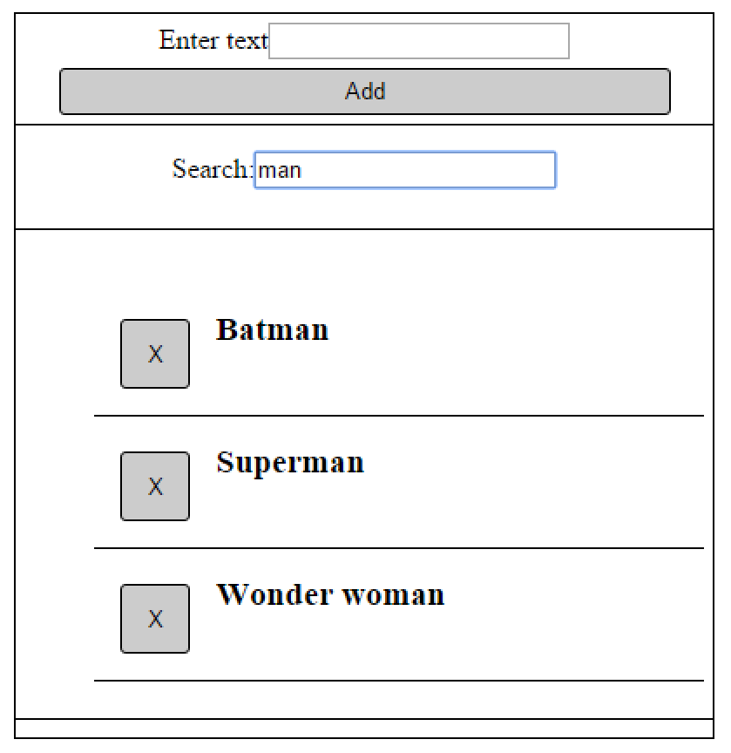

* After clicking the ‘X’ on “Green Lantern”

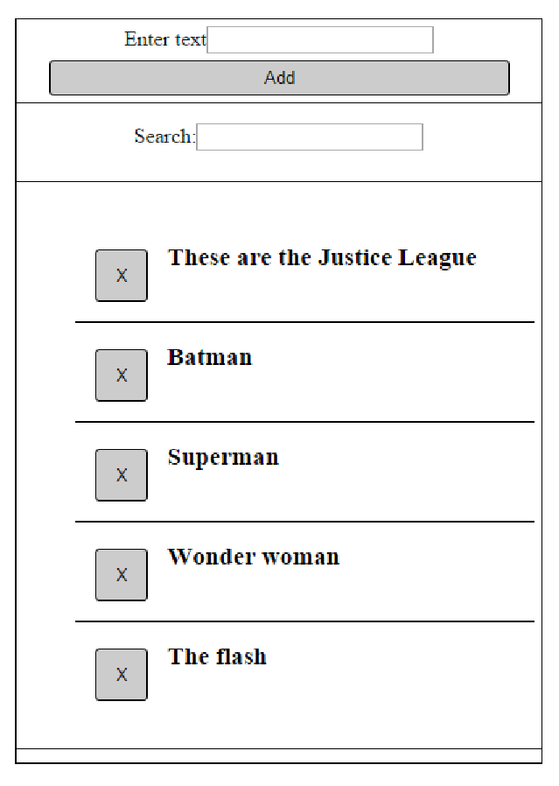

* When no item matches the pattern

